RankTrend.com is a webmaster tool and service that allows you to track related data over time and display it on powerful and flexible charts. In addition, RankTrend.com can be configured to automatically check the information you are interested in and email custom reports to you. Here are some of the features offered through this service.
Track the number of diggs for posts on Digg.com automatically
Track the number of people who bookmark a particular item on Del.icio.us
Track the rank of any site for any keyword phrase on Google, Yahoo or MSN.
Track the number of backlinks against any site on Google, Yahoo or MSN.
Track your Google Adsense revenue over time.
Track your Google PageRank over time.
Place events on your charts like changes to page structure, advertising campaigns, or article submissions so you can see what affect these activities have on your rank, your backlinks or any other data you want to track.
You can even use RSS feeds like blog entries & comments to add events automatically.
If RankTrend.com doesn’t already track the data you want, you can always use the Generic data source which can take a common or tab separated text file and import it. This allows you to plot the automatic data next to this manual data. If you come across datasources that you would like to track automatically, let us know and we’ll do what we can to add them per the number of requests and as time permits.

The remainder of this page will go over each feature in more detail.

Datasources
Datasources are the conduits that funnel data into RankTrend.com. For each datasource you set up, information can be automatically gathered and stored in the RankTrend.com database. You can then use it to view the results on powerful and flexible charts.
When you first create your RankTrend.com account and after you download the tray application, the first thing you will need to do is setup a datasource. To start just select add a datasource from the Control Panel. 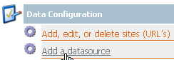
Once you add a datasource, data will show up in RankTrend.com within 1 hour (assuming you selected the default interval when configuring you tray application).
RankTrend has several automatic datasources for many of the most popular information resources. Use this page to set up your datasources.

Google Rank, Yahoo Rank & MSN Rank
For a given keyword phrase, RankTrend.com will track the rank of your site – or any other site – on all 3 of the major search engines. You can display the rank of multiple sites and from multiple search engines on a single chart – more on this in the Report section.
To set up one of the RankTrend.com datasources, select either Google Rank, Yahoo Rank or MSN Rank from the dropdown list and click Next. (at this time, you must create a datasource for each search engine that you want to track rank on – some of our early users have suggested we add the ability to do all 3 at once. We will do so in a future version of RankTrend.com)
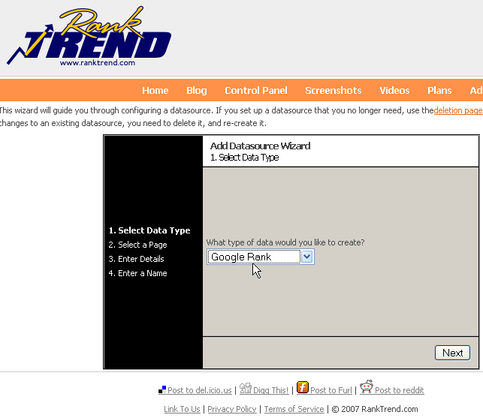
If you have already added some sites & pages through the Control Panel, just select one from the drop down list. If you haven’t added any, just type the full URL into the text box and click Add. Your site/page will be added and you can edit the details later. Click Next to add the keywords you want to track your rank for. 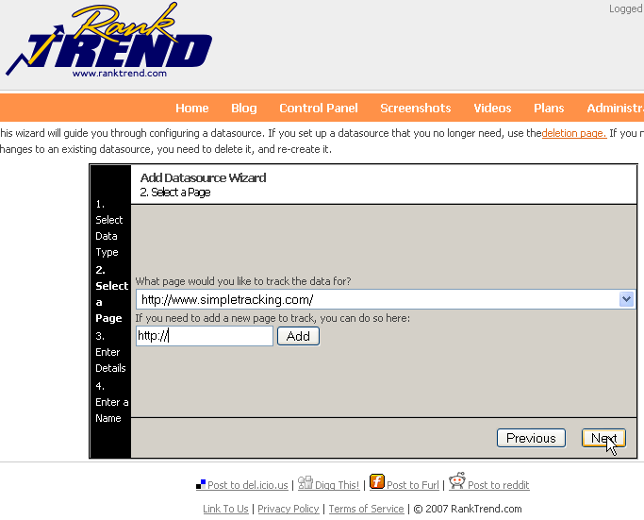
Enter the keyword phrase that you want to check your rank for and click next. 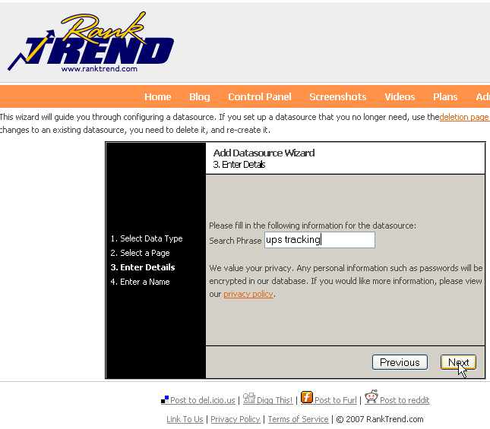
Finally, give your datasource a name so you can distinguish it the charts you will see later. The name defaults to the datasource type and the keyword you are tracking. Provide a short description if you like then click Finish. 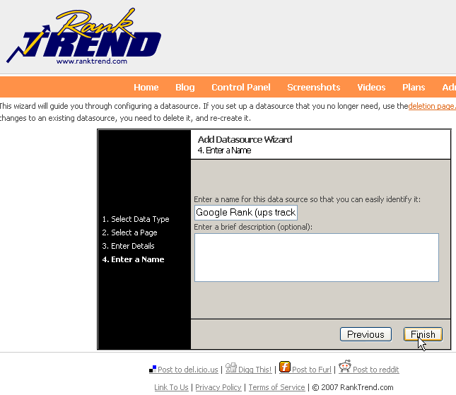
That’s it – with in an hour (depending on your tray application setting), you should see some data for the datasource. If you want to track the rank on other search engines, just repeat this process for each, choosing a different type in the first screen of the wizard.

Google PageRank
It’s not as important as it used to be but it’s still interesting so RankTrend.com allows you to track your Google PageRank over time and display it on a chart along with other related data such as your Google rank or backlink count. To start, just click the add datasource link from the Control Panel and select Google PageRank from the dropdown list then click Next.
If you have already added some sites & pages through the Control Panel, just select one from the drop down list. If you haven’t added any, just type the full URL into the text box and click Add. Your site/page will be added and you can edit the details later. Click Next to continue.
That is all you have to do to begin tracking PageRank, just click Next and \Finish on the subsequent wizard screens.

Google Adsense
Google Adsense data can be compared with your sites search engine ranking over time to help you see trends. When used with our automatic update and email feature it can give you a daily snapshot of your revenue right to your inbox. Click the add datasource link from the Control Panel, select Google Adsense from the dropdown list and click Next. 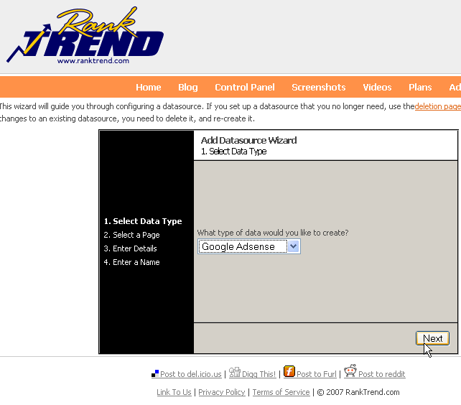
If you have already added some sites & pages through the Control Panel, just select one from the drop down list. If you haven’t added any, just type the full URL into the text box and click Add. Your site/page will be added and you can edit the details later. Click Next to continue.
On the next step you need to provide your Adsense account information. We do value your privacy and we are committed to keep this information private. Personal information such as passwords are encrypted in our secure database. If you would like more information, please view our privacy policy.
If you are unwilling to provide this information, the RankTrend.com import tool contains a Google Adsense CSV Report that allows you to put this data into RankTrend.com, see Import & Export section for details, unfortunately, this import process is not automated.
If you are willing to provide the login information, just enter your username, password and the channel of the Adsense setup you wish to track. 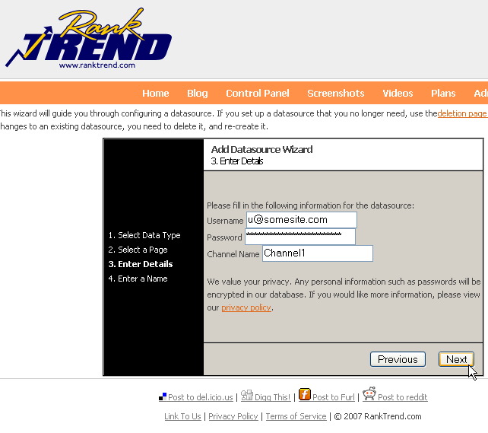
Complete the configuration by entering a datasource name and clicking Finish.

Google Backlinks (coming soon: Yahoo & MSN backlinks too),
Your backlinks tell you how many sites are linking back to you as far as the given search engine can tell. This can be useful in determining how popular your site is. To track your backlinks, click add datasource from the Control Panel, select Google Backlinks from the dropdown list and click next.
If you have already added some sites & pages through the Control Panel, just select one from the drop down list. If you haven’t added any, just type the full URL into the text box and click Add. Your site/page will be added and you can edit the details later. Click Next to continue.
That is all you have to do to begin tracking PageRank, just click Next and Finish on the subsequent wizard screens.

Digg
If you’ve ever had one of your pages posted on Digg you know that the more “diggs" you get the higher you page will rank in Digg and the more people will see it. RankTrend.com will automatically track this for you, all you have to do is insert the URL of the digg.com page you wish to track. RankTrend.com will take it from there and through our custom reports you can have your digg.com rank emailed to you daily. After clicking the add datasource link on the Control Panel, select Digg from the dropdown list and click Next
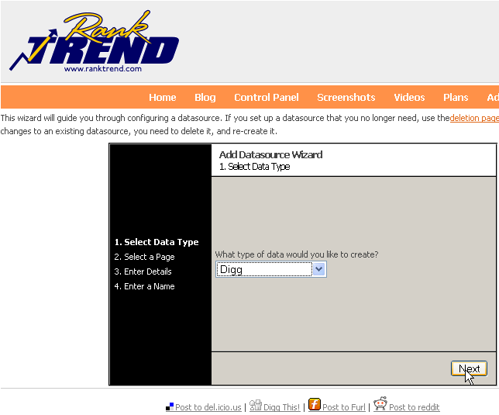
Select the site you want to associate this datasource with. For instance, perhaps you have a site that gets dugg a lot or perhaps you just want to track diggs for Washington Post articles. The site you select here lets you categorize the data together with other data about this site so you can generate reports on it. As with other datasources, you can add a new site here as well by typing the URL into the add site text box and clicking Add. After selecting your site, click Next to continue.
Add the Digg.com page you want track by typing the full URL into the text box. You can obtain this URL by going to Digg.com and selecting the post you want to track. 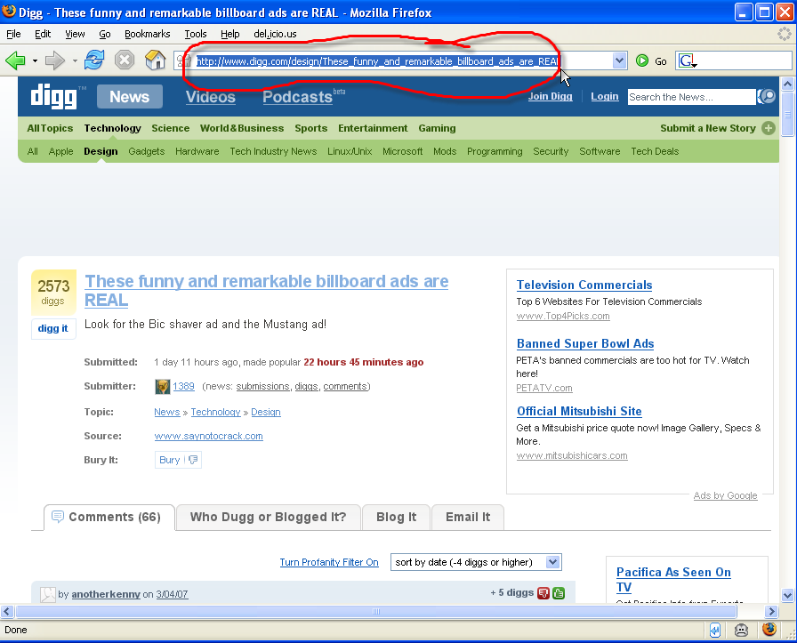
Make sure you are on the post you wish to track then copy the URL from the address bar of the browser to the Digg Story URL text box and click Next. .
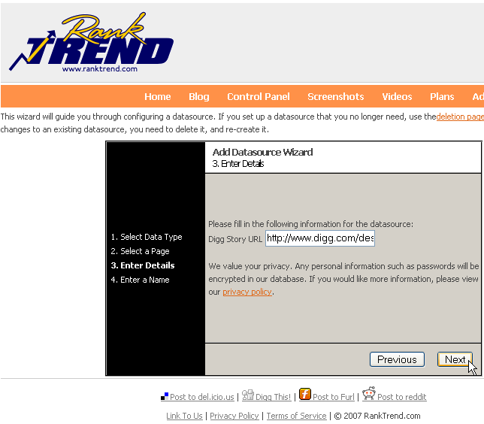
Enter a datasource name and short description if desired and click Finish.

Del.icio.us
You can track the number of other Del.icio.us members that bookmark any page that is on Del.icio.us. Combine this with data from other sources and you can begin to see trends.
To set up a Del.icio.us datasource, click the add datasource link on the Control Panel, select Del.icio.us from the dropdown list and click Next
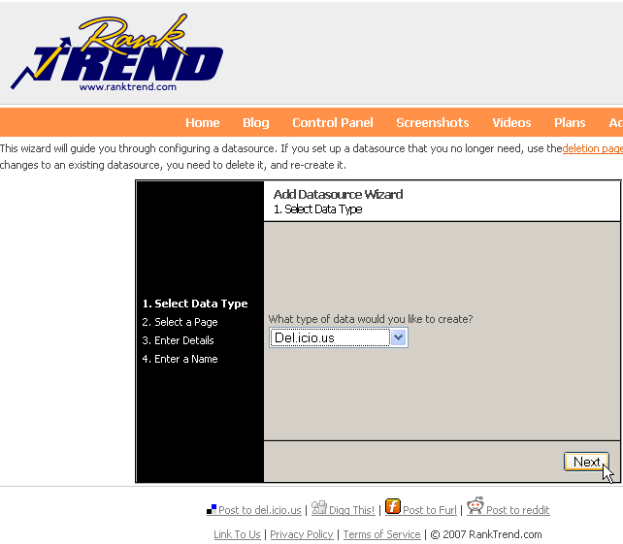
Select the site you want to associate this datasource with, in this case, the page you enter will be the page that is searched for in Del.icio.us. It is important to remember that Del.icio.us bookmarks are case sensitive and specific to a given page. In our example, the Del.icio.us bookmarks have “simpletracking” in all lower case letters. As with other datasources, you can add a new site here as well by typing the URL into the add site text box and clicking Add. After selecting your site, click Next to continue.
No other information is required for this datasource, simply click Next, then enter a datasource name and short description if desired and click Finish.

Generic
If one of the built in RankTrend.com datasources doesn’t meet your needs you can import data from a text file through the Generic datasource. Setting up a Generic datasource is very simple since no configuration data is required other than the site you want this data associated with and the name of the datasource. In the case of Generic datasources, the name of the Generic datasource actually has a bit more meaning because this will be how you select where imported data goes. To set up a Generic datasource, just click the add datasource link from the Control Panel and select the Generic data source and click Next
That’s all that’s required, just click Next and Finish after entering a descriptive name for this datasource (i.e. Bandwidth or Number of New Visitors).

Website Events
Events represent actions that took place at a given point in time or over a time frame. These actions can be placed on a chart to help you see the outcome of actions you had taken. For example, you can track your Google rank for a particular keyword after you submitted an article. Or you could track hits on your site after one of your pages was posted on Digg. Or you can track the number of comments added on your most recent blog post.

Manual Events
You can manually add events to RankTrend.com through the control panel. To add an event, just click the Add, edit or delete events link on the control panel. 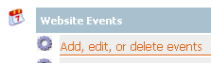
Remember to select the site from the top drop down list before you add your event. Events are specific to a site and cannot be shared across sites at this time.
Events can be a point in time like a single day by selecting the “Has End Date” checkbox next to the End date. 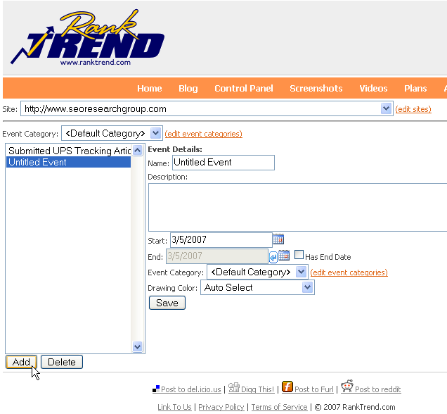Or events can go over a period of time, if for instance you are running an AdWords campaign for 7 days. Event Categories allow you to group events together for reporting. You can select a category when you set up your event or just let it go to your default category. The drawing color allows you to customize the color that is used to display the event on the chart.

Using RSS Feeds to create Events
One more very powerful feature of RankTrend.com is the ability to automatically add events from an RSS feed such as a blog post.
To set up an automatic RSS based event tracker, just click the Set up events that are automatically created from RSS feeds link from the Control Panel. 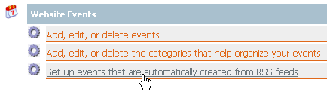
Select the site you want this data associated with from the dropdown list then click Add to create a new RSS subscription. .
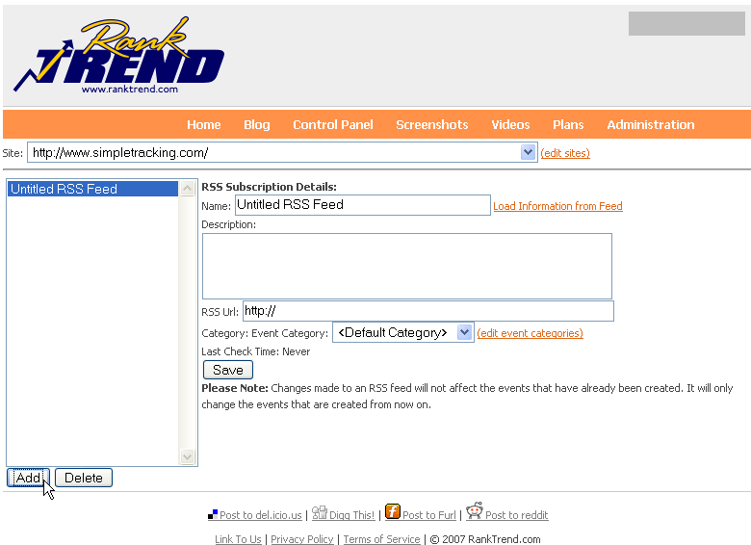
You can simple enter the subscription details but a shortcut is to enter the RSS Url then click the “Load information from feed” link to the right of the Name text box. This will import the feed name and description if there is one. 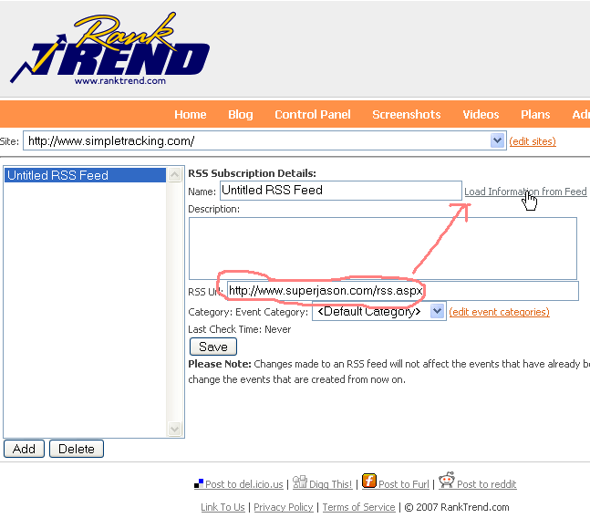
You can select an event category or edit it later.
Click Save to begin tracking you event data.

Categorize Events
You can categorize your events to make it easier and more effective to report on. Just select the categories link from the Control Panel under Website Events.
Remember to select the site from the top dropdown list.
Click the Add button, edit the category name and click save. 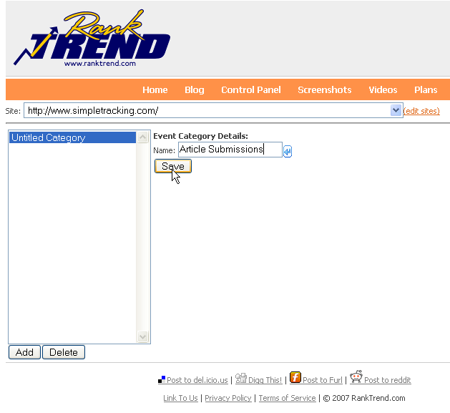

Reports
There are several built in reports available, in addition this section of the Control Panel allows you to build, use and save your interactive reports. 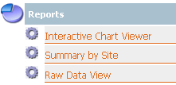
Interactive charts allow you to quickly build charts that can contain data from multiple sources. To open it just click the Interactive Chart Viewer link from the Reports section of the Control Panel.
Since nothing is currently on your chart you will start with a blank screen.
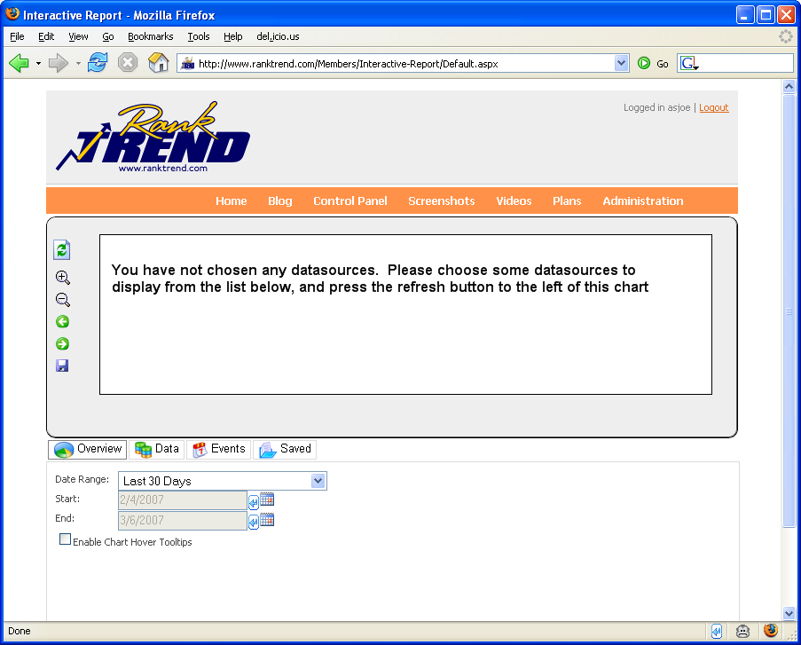
Choose the time range for the chart you want to build, we’ll leave the default at last 30 days.
Click the Data tab to add one of the datasources you have already created.
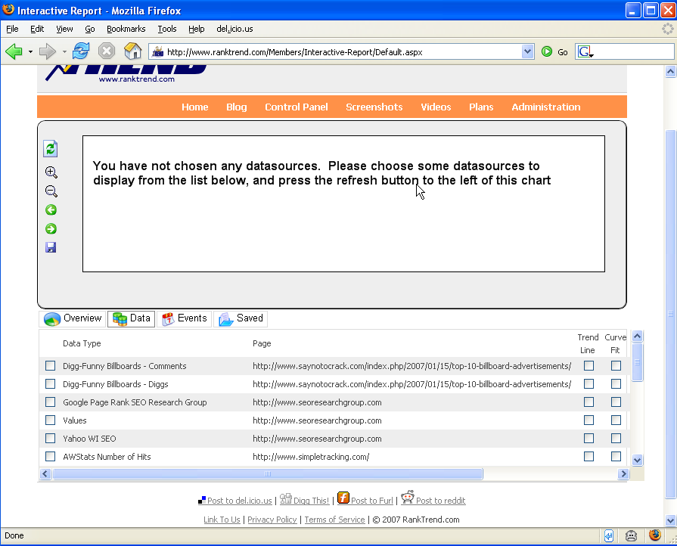
Then select at least 1 of your datasources then click the refresh button (top icon in the chart space). You must always click the refresh button when you make changes to your chart configuration.

Custom Reports
Details coming soon

Import & Export
Useful for pulling in historical data to any datasource type so you can get your site up and running as soon as possible. More details coming soon

Control Panel
Details coming soon

Tray Application
Details coming soon

